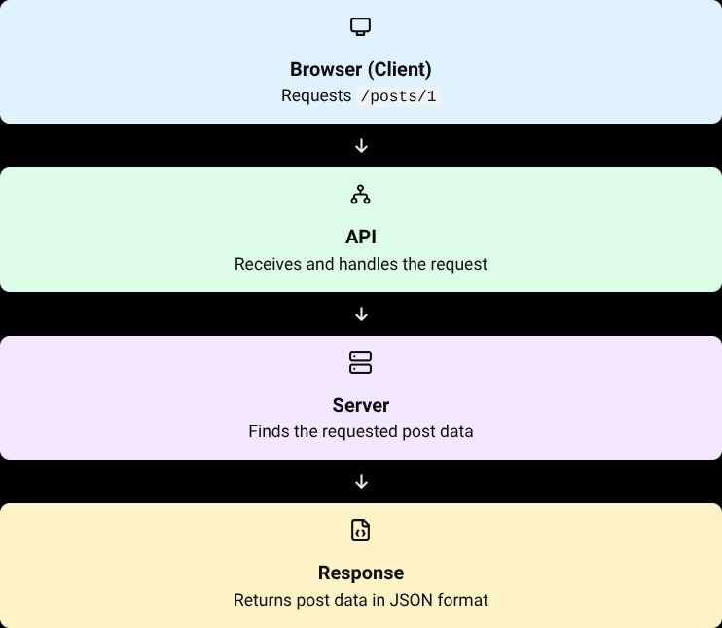
EXPLANATION:
When the browser requests /posts/1, it sends a request to the API. The API handles the request and the server retrieves the data for post ID 1. The server sends the requested data back through the API as a response. The browser displays the response in JSON format, including the post's ID, user ID, title, and body.

